AEM TASK DAY-4

1. Create a book detail page template

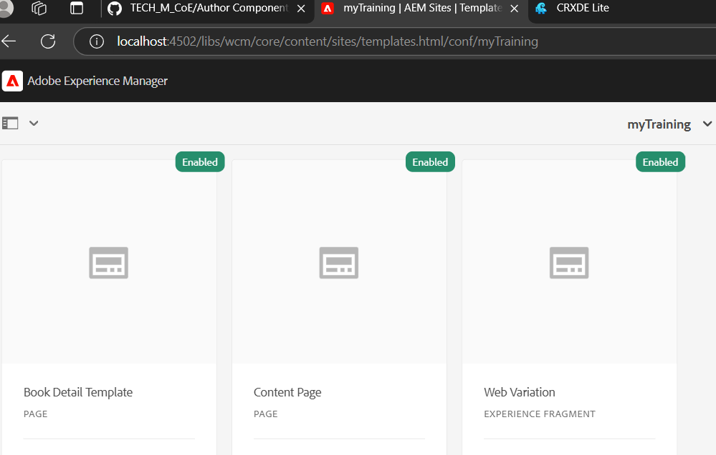

2.create book pages

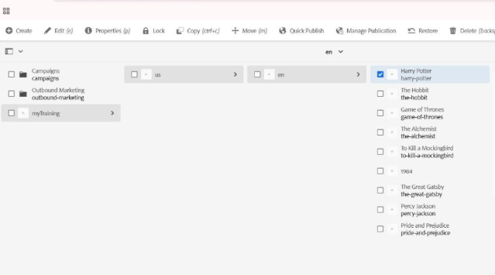

3.Search bar is provided to move to the user specified page

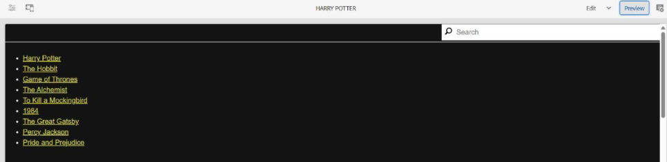

4.If clcik the title name ,it will navigate to that page



5.Footer

